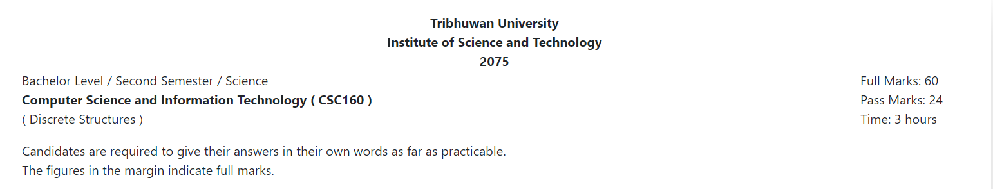

**Long answer questions:**

**Group A**

**Attempt any two questions:(2 x 10 = 20)**

1. What is S-D cut? For the following network flow find the maximal flow from S to D.

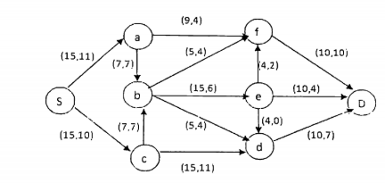

2. Consider a set U = { 1,2,3,4,5,6,7,8,9,10}. What will be the computer representation for set containing the numbers which are multiple of 3 not exceeding 6? Describe injective, surjective and bijective function with examples.

3.  Compute the following values.

a. 3 mod 4          b. 7 mod 5           c. -5 mod 3           d. 11 mod 5          e. -8  mod 6

Write down the recursive algorithm to find the value of bn and prove its correctness using induction.

**Short answer questions:**

**Group B**

**Attempt any eight questions:(8 x 5 = 40)**

4. Solve the recurrence relation an = 5an-1 - 6an-2with initial conditions a0= 1 and a1= 2.

5. Find the value of x such that x = 1 (mod 5) and x = 2 (mod 7) using Chinese remainder theorem.

6. Prove that 5n-1 is divisible by 4 using mathematical induction.

7. Let A = "Aldo is Italian" and B = "Bob is English". Formalize the following sentences in proposition.

a. Aldo isn't Italian.

b. Aldo is Italian while Bob is English.

c. If Aldo is Italian then Bob Bob is not English.

d. Aldo is Italian or if Aldo isn't Italian then Bob is English.

e. Either Aldo is Italian and Bob is English, or neither Aldo is Italian nor Bob is English.

8. Define Eular path and Hamilton path with examples. Draw the Hasse diagram for the divisible relation on the set { 1, 2, 5, 8, 16, 32} and find the maximal, minimal, greatest and least element if exist.

9. What does primality testing means? Describe how Fermat's Little Theorem tests for a prime number with suitable example.

10. List any two applications of conditional probability. You have 9 families you would like to invite to a wedding. Unfortunately, you can only invite 6 families. How many different sets of invitations could you write?

11. Define spanning tree and minimum spanning tree. Mention the conditions for two graphs for being isomorphic with an example.

12. Prove that the product xy is odd if and only if both x and y are odd integers .

**Tribhuwan University**

**Institute of Science and Technology**

**2076**

Bachelor Level / Second Semester / Science

**Computer Science and Information Technology ( CSC160 )**

( Discrete Structures )

Full Marks: 60

Pass Marks: 24

Time: 3 hours

Candidates are required to give their answers in their own words as far as practicable.

The figures in the margin indicate full marks.

**Group A**

**Long answer questions:**

**Attempt any two questions: (2 x 10 = 20)**

1. State pigeonhole principle. Solve the recurrence relation an= 3an-1-  3an-2+ an-3 with initial conditions a0=1 ,a1= 3, a2=7.

10 marks

2. Find the value of x such that x = 1 (mod 3), x = 1 (mod 4),  x = 1 (mod 5) and x = 0 (mod 7) using Chinese remainder theorem.

10 marks

3. Define Eular circuit with suitable example. Find the maximal flow s to t from the given network flow.

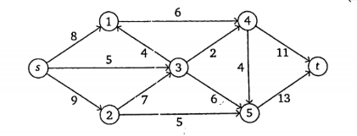

10 marks

**Group B**

**Short answer questions:**

**Attempt any eight questions: (8 x 5 = 40)**

4. Prove that for every positive integer n ≥ 1, n2+n is even integer using mathematical induction.

5 marks

5. All over smart people are stupid. Children of stupid people are naughty. John is a children of Jane. Jane is over smart. Represent these statements in FOPL and prove that John is naughty.

5 marks

6. Which of the following are posets?



5 marks

7. Define reflexive closure and symmetric closure. Find the remainder when 4x2 - x + 3  is divided by x + 2 using remainder theorem.

5 marks

8. Define Eular path and Hamilton path. Give examples of both Eular and Hamilton path.

5 marks

9. How many 3 digits numbers can be formed from the digits 1,2,3,4 and 5 assuming that:

a. Repetitions of digits are allowed

b. Repetitions of digits are not allowed

5 marks

10. What is minimum spannung tree? Explain Kruskal's algorithm for finding minimum spanning tree.

5 marks

11. List any two applications of graph coloring theorem. Prove that "A tree with n vertices has n-1 edges"

5 marks

12. Define ceiling and floor function. Why do we need Inclusion - Exclusion principle? Make it clear withsuitable example. 5 marks

**Tribhuvan University**

**Institute of Science and Technology**

**2078**

Bachelor Level / second-semester / Science

Computer Science and Information Technology( CSC165 )

Discrete Structure

Full Marks: 60 + 20 + 20

Pass Marks: 24 + 8 + 8

Time: 3 Hours

Candidates are required to give their answers in their own words as far as practicable.

The figures in the margin indicate full marks.

**Group A**

**Attempts any TWO questions**

1.Prove that for all integers x and y, if x2 + y2 is even then x + y is even. Using induction prove that 13 + 23 + 33 + ………………. + n3 = n2(n + 1)2 / 4

2.State division and remainder algorithm. Suppose that the domain of the propositional function P(x) consists of the integer 0, 1, 2, 3 and 4. Write out each of the following propositions using disjunctions, conjunctions and negations.

1. ∃x P(x)
2. ∀x P(x)
3. ∃x ¬P(x)
4. ∀x ¬P(x)
5. ¬∃x P(x)
6. ¬∀x P(x)

3.List all the necessary conditions for the graph to be isomorphic with an  example. Find the maximal flow from the node SOURCE to SINK in the following network flow.

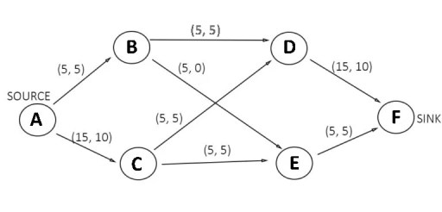

**Group B**

**Attempts any EIGHT questions**

4.What is the coefficient of x2 in (1 + x)11? Describe how relation can be represented using matrix.

5.Solve the recurrence relation an = 5an-1 – 6an-2 with initial conditions a0 = 1, a1 = 4.

6.Prove that if n is positive integer, then n is odd if and only if 5n + 6 is odd.

7.Define preposition. Consider the argument “John, a student in this class knows how to write program in C. Everyone who knows how to write program in C can get a high paying job. Therefore, someone in this class can get high paying job”. Now, explain which rules of inferences are sed for each step.

8.Show that if there are 30 students in a class, then at least two have same names that begin with the same letter. Explain the pascal’s triangle.

9.Illustrate the Dijkstra’s Algorithm to find the shortest path from source node to destination node with an example.

10.What are the significance of Minimum Spanning Tree? Describe how Kruskal’s algorithm can be used to find the MST.

11.Define zero-one matrix. Explain the types of function.

12.Represent any three set operations using Venn-diagram. Give a recursive defined function to find the factorial of any given positive integer.

**Tribhuvan University**

**Institute of Science and Technology**

**2079**

Bachelor Level / second-semester / Science

Computer Science and Information Technology( CSC165 )

Discrete Structure

Full Marks: 60 + 20 + 20

Pass Marks: 24 + 8 + 8

Time: 3 Hours

Candidates are required to give their answers in their own words as far as practicable.

The figures in the margin indicate full marks.

**Group A**

**Attemps any TWO questions (2 x 10 = 20)**

1.How do you plot the function on graph? Determine whether the function f(x) = x2 is injective, surjective or bijective with reasons. Solve the recurrence relation an = 6an-1 – 9an-2 with initial conditions a0 = 1 and a1 = 6.

2.A group of 8 scientist is composed of 5 chemist and 3 biologist. In how many ways can a committe of 5 be formed that has 3 chemist and 2 biologist? Using mathematical induction prove that 13 + 23 + 33 + ……………….. + n3 = n2(n + 1)2 / 4) for n ≥ 1.

3.Show that the relation R = {(a, b): |a – b| is even} is an equivalence relation in the set of integers. Given the following transport network with the edges labeled with their capacities, find all S-D and their capacities and What is the minimum capacity?

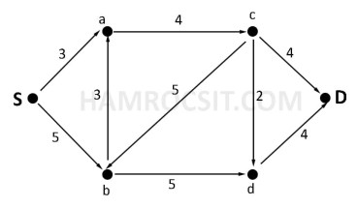

**Group B**

**Attemps any EIGHT questions (8 x 5 = 40)**

4.List any one example of tautology. Represent the following sentences into predicate logic.

1. Not all employees are loyal
2. All students having good attitude are lovable.

5.Prove that “If the product of two integers a and b are even then either a is even or b is even”, using the contradiction method.

6.Use Chinese Remainder Theorem to find the value of x such that x = 0 ( MOD 2) , x = 2 (MOD 3) and x = 3 (MOD 5).

7.Define bipartile graph with example. State the necessary conditions for the graphs to be isomorphic.

8.State Generalized Pigeonhole Principle. Find the MST from following graph using Kruskal algorithm.

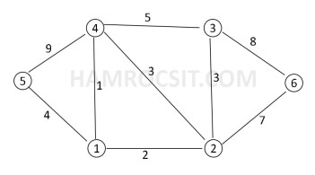

9.Given the premises “If it rains or strike holds then the exam will be cancelled. If the doesn’t rain then it will be sunny day. The exam was not cancelled. show that it is sunny day”.

10.Find the value of -2 MOD 3 and 315 MOD 5. Illustrate an example to show the join operation between any two boolean matrixes.

11.Given an example of fallacy. State the necessary and sufficient conditions for a graph to have Euler path and Euler circuit.

12.Find the GCD of 24 and 32 using Extended Euclidean algorithm.

